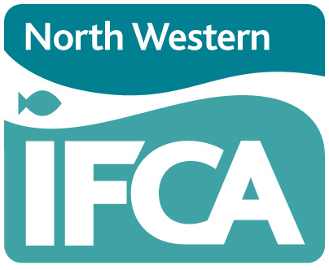
Technical, Science and Byelaws Sub-Committee
15th August 2023: 10.00am
Held at Truckhaven, Scotland Road, Carnforth LA5 9RQ

AGENDA

Lead Officer Report No.
- Appointment of Chair CEO
- Appointment of Vice-Chair Chair
- Chair’s Announcements and Apologies Chair
- Declarations of Interest Chair
- Minutes of TSB Meeting 9th May 2023 Chair
- Byelaw Update HoE Verbal
- Survey and Inspection Report Senior Scientist 1
- Science Report Senior Scientist 2
- North Wirral Foreshore CEO Verbal
- AOB Chair

