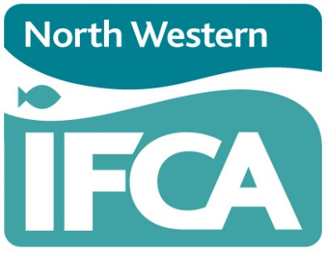
NWIFCA Quarterly Meeting
21st September 2023: 10:30 a.m.
Held at Truckhaven, Scotland Road, Carnforth Lancashire LA5 9RQ

Agenda
 |  | Lead | Report
1. | Chair’s Announcements and Apologies | Chair
2. | Declarations of Interest | Chair
3. | Minutes of NWIFCA AGM 22nd June 2023 | Chair
4. | Matters Arising | Chair
5. | Finance Report | CEO | 1
6. | Summary from Finance & Personnel 20th September 2023 | Chair F&P | Verbal
7. | Summary form TSB 15th August 2023 | Chair TSB | Verbal
8. | Chief Officers Report | CEO | 2
9. | Patrol and Enforcement Report | HoE | 3
10. | Science Report | Senior Scientist | 4
11. | Annual Report 2022-23 | CEO | 5
11. | Any Other Business | Chair | Verbal

