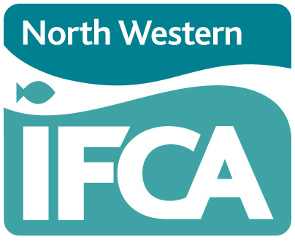
Technical, Science and Byelaws Sub-Committee
6th February 2024: 10.00am
Held at Truckhaven, Scotland Road, Carnforth LA5 9RQ

AGENDA

 |  | Lead Officer | Report  No.
1. | Chair’s Announcements and Apologies | Chair
2. | Declarations of Interest | Chair
3. | Minutes of TSB held 7th November 2023 | Chair
4. | Matters Arising | Chair
5. | Byelaw Update | Head of Enforcement | Verbal
6. | Survey and Inspection Report | Head of Science | 1
7. | Science Report | Head of Science | 2
8. | Cockle Open Season Proposal | Head of Science | 3
9. | Whelk MLS Work | Head of Science | 4
10. | Mussel Ephemerality | Head of Science | 5
11. | Next Meeting Date | Chair | Verbal
12 | Any Other Business | Chair | Verbal

