 | NORTH WESTERN INSHORE FISHERIES AND CONSERVATION AUTHORITY
 | www.nw-ifca.gov.uk | office@nw-ifca.gov.uk
 | 1 PRESTON STREET  CARNFORTH  LANCASHIRE, LA5 9BY |  | 6 DUNCAN SQUARE  WHITEHAVEN  CUMBRIA, CA28 7LN
 | Tel: (01524) 727970

NWIFCA Byelaw 3 Cockle and Mussel Hand Fishing Permit 2019 - Flexible Permit Conditions 2025.
Pilling Sands Cockle Fishery 2025
- Fishing is permitted from Saturday 4th January 2025 until Wednesday 30th April 2025.
- Fishing is permitted one tide per day, between Saturday and Wednesday. As specified in Annex A. Further tide times will be published by Friday 31st January 2025.
- Access and egress to the Fishery is only permitted from Pilling Embankment slipway. (Annex B). No other routes are to be used to access the fishery.
- Access to the fishery will be by ATV quad bike, 4x4 vehicle and shrimp tractor only.
- Parking of vehicles, or any ancillary activities of the fishery can only take place within the designated car parks adjacent to the slipway. (Annex B).
- The permitted fishing area is the enclosed area west of Pilling Embankment slipway due north as indicated by way of a closure boundary line as indicated by line A, as illustrated below in Annex C.
Point | Latitude  (decimal degrees) | Longitude  (decimal degrees) | Latitude (degrees, decimal minutes) | Longitude (degrees, decimal minutes)
A | 53.94270 | -2.93206 | 53° 56.562" N | 02° 55.923" N

- Cockles must be riddled on the cockle bed with undersize cockles distributed evenly back in the area they were gathered as soon as reasonably practical.
- The fishery is within a Marine Protected Area, as such required a Habitat Regulations Assessment (HRA). Should the fishery no longer be within the scope of information used to assess the fishery and there is potential for damage to protected features. The fishery will be suspended until further assessment has been carried out to ensure any fisheries remains HRA compliant.

Advisory Notes
- This permit does not exonerate the holder from any other sea fisheries legislation.

- Operate vehicles in a safe manner on the access road and when transiting to the fishery.

- Byelaw 3 permit holders should adhere to the Code of Conduct for Intertidal Shellfisheries.

- NWIFCA has the power to withdraw flexible permit conditions at any point should the need arise, subject to the review procedure.

- The fishery is in a Marine Protected Area (MPA) and has undergone a Habitats Regulations Assessment (HRA). With advice provided by Natural England, NWIFCA have concluded that there needs to be measures in place to minimise disturbance to pink-footed geese which roost at the site. NWIFCA will monitor the situation whilst at the fishery. NWIFCA request that fishers work with officers to ensure disturbance is kept to a minimum so that the fishery can remain HRA compliant and stay open for the remainder of the season. This may include delaying access to the fishery until the pink-footed geese have dispersed from their roost. It is requested that permit holders keep as much distance as possible between them and the pink-footed geese, reduce quad bike speed through the access route near the saltmarsh and the upper shore at dawn and dusk, keep the noise of the quad bike to a minimum by ensuring mufflers are working to further assist with reducing disturbance.

- Any breach of the conditions constitutes a breach of the byelaw.

- Please note under NWIFCA’s cold weather the fishery could be subject to closure during periods of cold weather https://www.nw-ifca.gov.uk/app/uploads/NORTH-WEST-IFCA-INTERTIDAL-FISHERY-COLD-WEATHER-PROTOCOL-WEBSITE-VERSION-1.pdf

By Order of the Authority
Mark Taylor
Chief Executive Officer
NWIFCA

Annex A – NWIFCA Byelaw 3 Pilling Sands Cockle Fishery Permitted Fishing Tides 2025

NWIFCA Byelaw 3 Pilling Cockle Fishery Permitted Fishing Days and Tides
January  2025 | Date | Day | Low Water Information
 |  |  | AM Tide | PM Tide
 |  |  | Time | Time
 | 1st | Wed | Fishery Closed | LW 18:48
 | 2nd | Thurs | Fishery Closed | Fishery Closed
 | 3rd | Fri | Fishery Closed | Fishery Closed
 | 4th | Sat | LW 08:22 | Fishery Closed
 | 5th | Sun | LW 09:05 | Fishery Closed
 | 6th | Mon | LW 09:51 | Fishery Closed
 | 7th | Tues | LW 10:45 | Fishery Closed
 | 8th | Wed | LW 11:48 | Fishery Closed
 | 9th | Thurs | Fishery Closed | Fishery Closed
 | 10th | Fri | Fishery Closed | Fishery Closed
 | 11th | Sat | Fishery Closed | LW 15:31
 | 12th | Sun | Fishery Closed | LW 16:35
 | 13th | Mon | Fishery Closed | LW 17:31
 | 14th | Tues | Fishery Closed | LW 18:21
 | 15th | Wed | Fishery Closed | LW 19:05
 | 16th | Thurs | Fishery Closed | Fishery Closed
 | 17th | Fri | Fishery Closed | Fishery Closed
 | 18th | Sat | LW 08:12 | Fishery Closed
 | 19th | Sun | LW 08:42 | Fishery Closed
 | 20th | Mon | LW 09:12 | Fishery Closed
 | 21st | Tues | LW 09:49 | Fishery Closed
 | 22nd | Wed | LW 10:36 | Fishery Closed
 | 23rd | Thurs | Fishery Closed | Fishery Closed
 | 24th | Fri | Fishery Closed | Fishery Closed
 | 25th | Sat | Fishery Closed | LW: 14:21
 | 26th | Sun | Fishery Closed | LW: 15:24
 | 27th | Mon | Fishery Closed | LW 16:18
 | 28th | Tues | Fishery Closed | LW 17:09
 | 29th | Wed | Fishery Closed | LW 17:56
 | 30th | Thurs | Fishery Closed | Fishery Closed
 | 31st | Fri | Fishery Closed | Fishery Closed

Annex B – NWIFCA Byelaw 3 Pilling Sands Cockle Fishery Permitted Access Route 2025
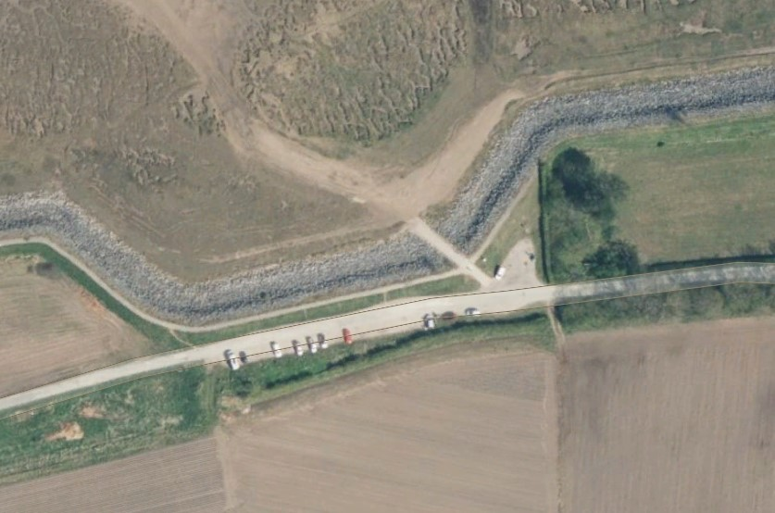
Car park area
Access point to Pilling Sands Cockle Fishery

Annex C – NWIFCA Byelaw 3 Pilling Sands Cockle Fishery Permitted Fishing Area 2025
